File Code: | 1950
Date: | May 18, 2015

Invitation to Comment – Please Reply by June 19, 2015
Fat Bike Trail Designations Project

Dear Interested Parties:

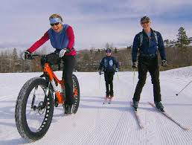
The USDA Forest Service is initiating an environmental analysis process for the proposed Fat Bike Trail Designations Project pursuant to the National Environmental Policy Act (NEPA). The project area is located on the Rochester and Middlebury Ranger Districts of the Green Mountain National Forest (GMNF) in the Towns of: Chittenden, Killington and Pittsfield (Rutland County); Rochester (Windsor County); Goshen and Ripton (Addison County); and Warren (Washington County), Vermont (refer to the attached maps).

The proposed action would designate approximately 37 miles of existing trails for fat bike use and would allow trail maintenance activities to maintain the trails to snow trail standards. Activities necessary to maintain the trails for fat biking would include: administrative grooming with a snowmobile (off a designated snowmobile trail), grooming through snowshoe compaction, or grooming with standard grooming equipment. Activities would also include sign changes at trailheads and trail intersections to indicate the managed uses for the trail network. No earth disturbance or tree felling is necessary. Please refer to the attached project information document for further details regarding the proposed action.

This proposed action potentially falls in a category of actions excluded from analysis in an Environmental Assessment or Environmental Impact Statement, as proposals of this type individually and cumulatively do not have a significant effect on the environment. This proposal appears to fall under category 36 CFR 220.6 (d) (4): “Repair and maintenance of roads, trails, and landline boundaries.”

I am interested to hear any concerns, issues or suggestions you may have regarding the proposed action. Please provide your comments to us by June 19, 2015. In your comments, please include the following information:
- Your name, address and telephone number or email address.
- The project you are commenting on: Fat Bike Trail Designations Project.
- Site specific comments about the proposal, such as what uses the trails should be managed for, along with supporting information and rationale you believe will help identify issues.
- Concerns about environmental effects associated with the proposal.

Submit your written comments in c/o Holly Knox via any of the following methods:
- Mail (verbal comments can also be given in person):
USDA Forest Service – Rochester Ranger District
99 Ranger Road
Rochester, VT 05767
- Email: comments-eastern-green-mt-finger-lakes-rochester@fs.fed.us
- Phone: (802) 767-4261 x 530
- Facsimile: (802) 767-4777

Comments received in response to this invitation, including name and address of those who comment, will be considered part of the public record for this project and will be available for public review. Additional information regarding the proposal can be obtained from: Holly Knox, Rochester Ranger District, 99 Ranger Road, Rochester, VT 05767, (802) 767-4261 ext. 530 or email at hknox@fs.fed.us.

Thank you for your interest in the Green Mountain National Forest. I look forward to hearing from you.

/s/ Christopher Mattrick

Christopher Mattrick
District Ranger – Rochester & Middlebury Ranger Districts
Green Mountain National Forest
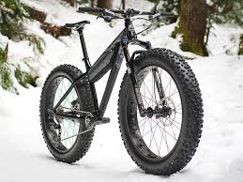
Enclosures: Project information and map

